Accepted Manuscript

Intensified warming of the Arctic: Causes and impacts on middle latitudes

John E. Walsh

PII: S0921-8181(14)00057-5
DOI: doi: 10.1016/j.gloplacha.2014.03.003
Reference: GLOBAL 2101

To appear in: Global and Planetary Change

Received date: 15 August 2013
Revised date: 3 March 2014
Accepted date: 7 March 2014

Please cite this article as: Walsh, John E., Intensiﬁed warming of the Arctic: Causes and impacts on middle latitudes, Global and Planetary Change (2014), doi:
10.1016/j.gloplacha.2014.03.003

This is a PDF ﬁle of an unedited manuscript that has been accepted for publication. As a service to our customers we are providing this early version of the manuscript. The manuscript will undergo copyediting, typesetting, and review of the resulting proof before it is published in its ﬁnal form. Please note that during the production process errors may be discovered which could aﬀect the content, and all legal disclaimers that apply to the journal pertain.

Intensified warming of the Arctic: Causes and impacts on middle latitudes

John E. Walsh

International Arctic Research Center, University of Alaska, Fairbanks, Alaska, USA

Revised March 2014

Corresponding author address: International Arctic Research Center
University of Alaska
930 Koyukuk Drive
Fairbanks, AK 99775 USA Email: jwalsh@iarc.uaf.edu

ABSTRACT

Over the past half century, the Arctic has warmed at about twice the global rate. The reduction of sea ice and snow cover has contributed to the high-latitude warming, as the maximum of the amplification during autumn is a fingerprint of the ice-albedo feedback. There is evidence that atmospheric water vapor, a greenhouse gas, has increased in the Arctic over the past several decades. Ocean heat fluxes into the Arctic from the North Atlantic and North Pacific have also contributed to the Arctic warming through a reduction of sea ice. Observational and modeling studies suggest that reduced sea ice cover and a warmer Arctic in autumn may affect the middle latitudes by weakening the west-to-east wind speeds in the upper atmosphere, by increasing the frequency of wintertime blocking events that in turn lead to persistence or slower propagation of anomalous temperatures in middle latitudes, and by increasing continental snow cover that can in turn influence the atmospheric circulation. While these effects on middle latitudes have been suggested by some analyses, natural variability has thus far precluded a conclusive demonstration of an impact of the Arctic on mid-latitude weather and climate.

Keywords: climate, Arctic warming, polar amplification, sea ice, climate impacts

1. Introduction

Several decades ago, the Arctic was an afterthought in climate change research. Today it is at the forefront. The recent acceleration of research on Arctic climate, together with widespread coverage by the media and interest by the public, has come in response to rapid changes in the Arctic over the past few decades. By some measures, these changes are unprecedented. While the changes are driven by warming of the ocean and atmosphere, they are manifested in sea ice, glaciers, ice sheets, permafrost and other components of the Arctic system. The Arctic changes are even more intriguing because they are expected to play, and may already be playing, a role in further changes that impact middle latitudes and the rest of the globe. As evidence of the increased public awareness of this topic, Hamilton and Lemcke-Stampone (2013) have recently reported results showing that a clear majority (60%) of surveyed members of the public now accepts that there is a connection between Arctic warming and mid-latitude weather. Is such acceptance justified? This question motivates the present paper, which has two main objectives. The first is an assessment of our present understanding of the causes of the recent changes in the Arctic, with an
emphasis on the warming that has contributed to changes in various other components of the Arctic system. Because such an assessment requires consideration of some other system components that may have amplified the recent changes, linkages with the global climate system will be prominent in the discussion. A second related objective is a synthesis of our current understanding of the impacts of Arctic change on middle latitudes. While this understanding is rapidly evolving, we will present emerging evidence that the Arctic is already impacting mid-latitude climate over monthly to multiyear timescales. Section 2 provides information on the recent Arctic warming, while Sections 3 and 4 address the paper’s two main objectives by assessing the causes and impacts, respectively. Some concluding thoughts on the future trajectory of Arctic climate are presented in Section 5.

2. The recent warming

Figure 1 shows the change of annual mean temperature over the extratropical Northern Hemisphere during the past 50 years, 1963-2012. Warming dominates and increases poleward, consistent with the notion of polar amplification. The warming in Figure 1 is strongest over the Arctic Ocean, where it ranges from 2 to 4ºC. In middle latitudes, the warming is generally greater over land than over the ocean. It should be noted that polar amplification also characterizes cooling episodes, such as occurred over the Northern Hemisphere from the 1940s through the 1970s (e.g., Serreze et al., 2009).
The Arctic warming of the past half-century appears to be unique in the past 2000 years, at least during the summer season. Kaufman et al. (2009) provided a reconstruction of pan-Arctic temperatures based on various types of proxy information, including lake sediments, pollen records, diatoms and tree rings. According to this reconstruction, the Arctic showed a slow cooling trend for most of the past 2000 years, consistent with variations of the Earth-Sun orbital parameters. However, the recent warming has taken Arctic temperatures outside the range of the previous 2000 years of temperature variations. It should be emphasized, however, that the information used in this reconstruction was indicative primarily of summer temperatures.
The recent Arctic warming has been accompanied by a rapid loss of sea ice, especially during the warm season. September sea ice extent in 2012 fell to approximately
50% of the mean for the 1979-2000 period (Figures 2 and 3). (Consistent measurements by satellite passive microwave sensors began in 1979). The recent decline is unprecedented in the satellite record and in paleo reconstructions spanning more than 1400 years (Kinnard et al., 2011).
As shown in Figure 4, extreme sea ice retreats have characterized Arctic sea ice from

2007 onward; these retreats appear in Figure 4 as large negative departures from the

previous means in the summer and autumn seasons. It is apparent from Figure 2 as well as Figure 4 that the recent reduction of sea ice has been much less in winter and spring than in summer and autumn, resulting in a sea ice cover that is largely seasonal. The increasingly seasonal ice cover contrasts with the Arctic Ocean’s predominantly multiyear ice pack of the pre-2000 decades. Consistent with the seasonality of the loss of sea ice, some marginal seas such as the Bering show little trend in ice coverage over the past 30 years. However,
seasonal ice in the Bering Sea and elsewhere in the Arctic is thin and susceptible to rapid melt during the following summer. The seasonality of Arctic sea ice loss is highlighted here because it has direct relevance to the interpretation of the drivers as well as the impacts of Arctic temperature change, as discussed in the following two sections.
When compared to the reductions of ice extent, the percentage reductions of ice volume and thickness are even greater. Ice thickness decreased by more than 50% from
1958-1976 to 2003-2008 (Kwok and Rothrock, 2009), and the percentage of the March ice cover made up of thicker multiyear ice (ice that has survived a summer melt season) decreased from 75% in the mid-1980s to 45% in 2011 (Maslanik et al., 2011). Laxon et al., (2013) indicate an even greater decrease of 64% in autumn sea ice volume from 2003-08 to
2012.

Changes in other cryospheric variables, including terrestrial snow cover, permafrost, glaciers and ice sheets, are summarized in Snow, Water, Ice and Permafrost in the Arctic, a synthesis report published recently by the Arctic Monitoring and Assessment Programme (AMAP, 2011). The changes in these other variables are consistent with a warming Arctic
in recent decades. Because the primary focus of the present paper is the Arctic warming, we refer the reader to the AMAP report for additional information on recent changes in other components of the Arctic’s physical system.

3. Drivers of the amplified warming in the Arctic

An explanation of the recent Arctic warming and associated sea ice loss has become one of the grand challenges of Arctic research (Kattsov et al., 2010). Three factors have been identified as contributors to the polar amplification:
• the albedo-temperature feedback associated with a reduction of sea ice

• increased atmospheric humidity and the associated increase of downwelling longwave radiation
• increased poleward transports by the ocean and atmosphere

While these drivers are not independent (e.g., the loss of sea ice can be driven by warming associated with increased humidity or poleward transports), we cover them sequentially in the interest of a more structured presentation.

3.1 The albedo-temperature feedback

Evidence for an impact of reduced sea ice and snow cover on air temperature is provided by Figure 5, which shows the warming of the most recent six years (2007-2012) relative to the mean for 1971-2000. The warming, plotted as a function of calendar month and latitude, is strongest over the Arctic Ocean (70-90ºN) during the period September-December. This period coincides with the greatest loss of sea ice, as shown earlier. The reduction of the reflective sea ice cover during the season of strong solar radiation enables the upper ocean to absorb heat for release back to the atmosphere during the autumn and early winter
(Perovich and Richter-Menge 2009), when cooling would be most rapid in the presence of sea ice. The signature of this release of stored heat by the high-latitude ocean is unmistakeable in Figure 5.
Figure 5 also shows a secondary maximum of warming in the northern high latitudes during spring. This maximum is consistent with the earlier disappearance of snow over

northern land areas. Snow cover on land has decreased over the past several decades (Shi et al., 2013), especially in spring (Derksen and Brown, 2012). In percentage terms, the decline in end-of-season (June) snow cover has actually been more pronounced (-18% per decade) than the more publicized decline in end-of-melt-season (September) sea ice (-11% per decade). As with the loss of sea ice over the ocean, the loss of springtime snow cover enables the less reflective land surface to absorb greater amounts of incoming solar
radiation, thereby contributing to warmer spring conditions in the northern high latitudes. Because land has a smaller heat capacity than the ocean, there is less seasonal lag in the warming relative to the loss of terrestrial snow cover compared to the loss of sea ice.

3.2. Increased atmospheric humidity and associated downwelling radiation

The saturation vapour pressure (water vapor-holding capacity) of air increases with temperature. If air’s relative humidity (the ratio of its actual moisture content to its saturation value) remains approximately constant, the air’s actual humidity can be expected to increase in a warming climate. Water vapor, in turn, is a strong greenhouse gas. Increases in humidity can therefore be expected to result in additional trapping of the infrared radiation emitted by the Earth. The corresponding increase in downwelling radiation will then enhance the warming of the surface. Even before the recent decline of sea ice, Francis and Hunter (2006) showed that variability of downwelling radiation was
associated with sea ice variations on interannual timescales. Since a loss of sea ice leads to increased atmospheric moisture, which then increases the downwelling radiation and warming of the surface, the Arctic is a prime candidate for a manifestation of the so-called “water vapor feedback” and amplification of surface warming. Another reason why the Arctic should be sensitive to the water vapour feedback is because its atmosphere is very

dry, especially in winter, so even a small increase in moisture can have a relatively large impact on the downwelling longwave radiation reaching the surface..
Several recent studies confirm recent increases of humidity in the Arctic. Screen and Simmonds (2010) present evidence that the increase of humidity in recent decades has arisen largely from the reduction of sea ice and has contributed to the Arctic warming, especially during summer and early autumn. The increases of humidity reported by Screen and Simmonds have been largest over the Arctic Ocean. Serreze et al. (2012) used a set of three atmospheric reanalyses as well as rawinsonde data to document humidity changes poleward of 60°N. While the increases varied by season and location, all sources showed increases of precipitable water in the surface-500 hPa layer over the period 1979-2010. Cohen et al. (2013) show that the recent increase is especially large in September-October and is consistent with other changes that we discuss in Section 4.
While the water vapour feedback appears to have emerged as a contributor to Arctic amplification, changes in cloudiness are also considered to be candidates for feedbacks to climate change in high latitudes. As is the case with water vapor, clouds trap longwave (infrared) radiation and have a net warming effect on the Arctic surface in all seasons except for a portion of the summer (Curry et al., 1993; Walsh et al., 1998). Studies by Eastman
and Warren (2010) and Vavrus et al. (2011), using observational data and a climate model, respectively, showed increases of clouds in the Arctic during autumn, although Vavrus et al. trend in found that the positive summertime Arctic cloud cover was reduced during periods of rapid sea ice loss in model simulations of the first half of the 21st century. Screen and Simmonds (2010) concluded that changes in cloudiness have played a much smaller role than changes in sea ice and atmospheric water vapor in the recent Arctic warming, and this conclusion is supported by the more recent results of Ghatak and Miller (2013). Given the tenuous nature of the evidence to date (and the difficulty of systematically documenting

changes in Arctic clouds and their radiative properties), the jury still appears to be out in the assessment of the role of clouds in the recent and future Arctic amplification.
Impacts of increased water vapor are intertwined with increases in downwelling longwave radiation resulting from warmer air temperatures in the lower troposphere. The recent warming of the Arctic is strongest near the surface and diminishes upward (Section
4). Since most of the downwelling longwave radiation that reaches the surface is emitted in the lowest kilometre of the atmosphere, warming of this layer will increase the downwelling longwave radiation at the surface. Bintanja and van der Linden (2013) show that the combined effect of warmer lower troposphere and increased water vapour, which together comprise their “infrared feedback”, outweigh the ice-albedo feedback by about 3:1 in amplifying Arctic winter warming. While this finding is based on radiation fluxes from an atmospheric reanalysis and global climate models simulations, it is consistent with the seasonality of the recent observed Arctic warming. It is also consistent with Ghatak and Miller’s (2013) finding that the contribution of increased water vapor to downwelling longwave flux and Arctic warming is highly seasonal, with a maximum in winter and a minimum in summer.
Another factor contributing to the strong near-surface warming in the Arctic is the strong static stability of the near-surface layers of both the atmosphere and the ocean in the Arctic. The strong stratification, manifested in the atmosphere as near-surface temperature
inversions that are especially strong in winter, concentrates the additional heating in a shallow layer, thereby favoring large temperature increases.

3.3. Increased poleward transports by the ocean and atmosphere

Poleward transports of heat and moisture are key components of the Arctic’s energy

budget (Serreze and Barry, 2007). These transports are achieved by the ocean and

atmosphere through their respective circulations (currents and winds). Figure 6 provides an example of the varying temperature of North Atlantic Ocean inflow to the Arctic Ocean. This inflow occurs in two main branches, one west of Svalbard and the other through the Barents Sea. This inflow is characterized by decadal and multidecadal variations superimposed on a warming trend (Polyakov et al., 2010). The time series in Figure 6 is the temperature of the western branch, measured northwest of Svalbard. The combination of variability and the underlying trend leads to increasingly warm inflow pulses, one of which occurred in 2005-2006, immediately prior to the extreme ice retreat of 2007 (Section 2). Figure 6 also shows cross-sections of the water column northeast of Svalbard in 2004, 2006 and 2008, illustrating the passage of this warm pulse. Because this Atlantic water circulates in a counterclockwise sense at depths of 100-400 m around the Arctic Basin, with a timescale of several years, measurements of abrupt warming of the Atlantic layer north of Siberia during 2007-2009 are consistent with the inflow pulse of 2005-2006 in Figure 6
(Polyakov et al., 2011). The corresponding loss of sea ice along its North Atlantic margin is also shown in Figure 6.
The corridor for Pacific Ocean water entering the Arctic is Bering Strait. This water has also warmed over the past decade (Woodgate et al., 2012). Moreover, there are indications that this increased heating reduces the thickness and coverage of sea ice in the Beaufort, Chukchi and East Siberian Seas. The thinner ice, in turn, is more mobile and responsive to winds that drive the Beaufort gyre, enabling transports of the warmer Pacific water from the continental shelves to the deeper Arctic Ocean (Shimada et al., 2006). The further melt of sea ice then contributes to the albedo-temperature feedback discussed earlier. The fact that the recent retreat of sea ice has been largest in this sector attests to the importance of Pacific Water inflow for the Arctic and its recent warming.

Atmospheric transports of heat and moisture into the Arctic can also be expected to increase as the atmosphere in lower latitudes becomes warmer and more moist. While changes in the mid-latitude atmosphere are the focus of Section 4, we show here a time series of the poleward transport of moisture (specific humidity) across 75°N based on an atmospheric reanalysis. As with the ocean transports, variability is prominent (Figure 7). However, there is a notable peak in the 2005-2006 time period, immediately prior to the abrupt shift towards summers of extreme sea ice retreat. As noted in Section 3.2, the moisture content of the Arctic atmosphere has increased in recent decades. While there is no systematic trend in the poleward moisture transport into the Arctic in Figure 7, the has
been an increase in open-water season length over the Arctic Ocean as well as an increase in the snow-free period over land, suggesting that evapotranspiration may have increased. However, direct observations of evapotranspiration are not available, and the relative contributions of poleward transports and local evaporation (evapotranspiration over land) to this overall increase of Arctic humidity remains an active research area.

4. Arctic warming’s impacts on middle latitudes

As noted in the Introduction, a topic of increasing interest is the impact of Arctic warming and sea ice loss on middle latitudes via the large-scale circulation. Because the atmospheric circulation is ultimately driven by horizontal gradients of temperature and by processes involving moisture, larger-scale impacts of a warmer and ice-diminished Arctic are plausible. The nature and magnitude of any such signals embedded in the atmosphere’s internal variability are the subject of this section.
Two mechanisms have recently been proposed for linking changes in the Arctic and middle latitudes via the atmospheric circulation. The first is based on the impact of Arctic warming on the pressure (geopotential height) fields in the Arctic and a role of these

changes in the increased frequency of blocking in middle latitudes. The second is an Arctic- midlatitude connection via Eurasian snow cover. Both mechanisms are rooted in the atmospheric heating patterns that determine the three-dimensional pressure distribution, which in turn drives the atmospheric circulation. Since the preceding discussion has been limited to changes at the Arctic surface (and the underlying ocean), we now illustrate the vertical distribution of the recent changes in the atmosphere.

4.1 Impacts on geopotential heights and blocking events

Extending the analysis of Overland and Wang (2010), Figure 8 shows the zonal mean

(i.e., longitudinally averaged) temperature for 2007-2012, plotted as departures from the

1971-2000 averages, as a function of latitude and height (pressure) in the atmosphere. The

2007-2012 period spans the recent period of accelerated summer/autumn ice loss. The two panels in Figure 8 show the warming in October-November and January February (the latter for the winters of 2008-2013). It is apparent that the strongest warming is in the Arctic and
is surface-based, confirming the importance of sea ice loss in the recent warming (Section

2). The warming is more widespread during October-November, exceeding 2.5°C over the Arctic Ocean and 1.5ºC in the lowest kilometer (150 hPa) at all latitudes down to 65ºN. In the middle troposphere, the warming over the Arctic is typically 0.5-1.0ºC. Weak cooling is indicated in the upper troposphere and lower stratosphere. During January-February, the warming is again surface-based and strongest in the Arctic, although values exceeding 2ºC are confined to the lower troposphere over 70-85ºN. The southward shift of the maximum warming in winter is consistent with the southward migration of the sea ice edge from autumn to winter.
While the cross-sections in Figure 8 point to surface heating as a factor in the higher geopotential heights, but they do not distinguish the impacts of sea ice and snow cover, both

of which have seen their extent reduced in recent years. However, two lines of reasoning favour sea ice rather than snow as the dominant driver of the increased heights. First, the near-surface warming is greatest in autumn (Figure 5), when the albedo effect in high latitudes is weak but the release of oceanic heat to a cooling atmosphere is strong. By comparison, the autumn heat release from land surfaces is small, even without snow cover.. Second, the latitudinal bands of the maximum near-surface heating in Figures 8 are found near the marginal ice zone, north of the latitudes of the terrestrial snow boundaries. Hence the loss of sea ice is the primary candidate for an explanation of the temperature signals in Figure 8.
Heating of the lower atmosphere can be expected to raise the pressures aloft by thermal expansion, which increases the thickness of the air column between two pressures. Figure 9 shows that pressures have indeed increased aloft above the latitudes of warming in the Arctic. Overland et al. (2011) show how this type of atmospheric signature characterized the recent winters with abnormal warmth in the Arctic and extreme cold in middle latitudes,
particularly Europe. While the latitude-height distribution of the pressure changes is similar in autumn and winter, the increases in the upper atmosphere are considerably larger in autumn (note the different color scales in the two panels of Figure 9) , consistent with the stronger low-level warming in autumn. However, in both seasons, the north-south gradients of the pressure changes in the upper atmosphere result in changes in the zonal (west-to-east) winds, as shown in Figure 10. Because the changes in Figure 9 reduce the normal north-to- south gradient of pressure, the zonal winds weaken. This weakening is especially apparent during winter (January-February) over the 45-65ºN latitude belt (Figure 10b). Figure 11 (shows a time series of the average zonal wind speed at 500 hPa for the late autumn/early winter period, October-December. The correspondence with the decrease of autumn sea ice area is apparent, as one would expect if Arctic heating driven by sea ice loss is contributing

to the reduction of westerly winds. However, Figure 11 also contains indications of multdecadal variability, with generally low values (comparable to the late 2000s) from the mid-1950s through the 1960s, and higher values from the late 1970s through the 1990s. While the time series of autumn sea ice and mid-latitude zonal wind speeds are positively correlated over the past few decades, the correlation is primarily due to the trend and vanishes when the time series are extended to include pre-satellite decades (Figure 11). Although the pre-satellite data are known to be lees homogeneous than the post-1979 sea ice data (Meier et al., 2012), the divergence of the time series of sea ice and zonal wind as one
goes back to the 1960s and 1950s indicates that there is no robust relationship, at least on the hemispheric scale, between the two variables.
As the west-east component of windspeed weakens, the north-south meanders in the atmosphere’s jet stream can be expected to become more prominent. These meanders, known as troughs (southward dips) and ridges (northward bulges), are shown schematically in Figure 12. The troughs and ridges in the jetstream represent, respectively, southward intrusions of polar air into middle latitudes and northward intrusions of warmer air into higher latitudes. Amplified waves with long wavelengths tend to propagate eastward more slowly than shorter, small-amplitude waves. As a result, the more amplified pattern tends to be associated with persistent periods of anomalous and often extreme weather in middle latitudes. Francis and Vavrus (2012) show that zonal wind speeds have indeed decreased and wave amplitudes have increased over the period since 1979 during winter as well as autumn, especially in the Atlantic hemisphere. These changes are consistent with polar- amplified warming (which also favors northward extensions of atmospheric ridges) and they are consistent with periods of extreme winter weather in middle latitudes in recent years. Such periods are often referred to as “blocking” episodes, as the large-amplitude waves (often with closed pressure centers embedded in the highly amplified waves) effectively

block the eastward propagation of the upper-air features that dictate surface weather regimes. However, Screen and Simmons (2013) show that conclusions about such changes are sensitive to the metric of wave activity and to the choice of geographical region. Barnes (2013) obtained a similar conclusion and also showed that the frequency of blocking has shown no significant increase in the post-1980 period, while Hopsch et al. (2012a) concluded that relationships between autumn sea ice and the winter atmospheric circulation “are not yet robust enough from a statistical perspective”. Nevertheless, modelling studies have suggested an association between Arctic warming and colder winters over the United States and much of Eurasia. In one of the earliest experiments with a global climate model, Newson (1973) examined the effect of the removal of sea ice in the U.K. Meteorological Office’s global model. While the surface temperatures in the Arctic warmed dramatically
when sea ice was replaced by open ocean during winter, temperatures indeed decreased over the mid-latitude land areas. A similar response was obtained by Warshaw and Rapp (1973) using a different model, the Mintz-Arakawa global circulation model. More recent experiments by Honda et al. (2009) showed that reduced ice cover north of Siberia also
leads to abnormally cold temperatures over much of Eurasia, including Japan, during the winter months. A corresponding observational data analysis by Honda et al. showed similar relationships between sea ice and winter temperature anomalies. The validity of a connection between Barents-Kara sea ice during autumn and the midlatitude winter circulation was further supported by the model experiments of Petoukhov and Semenov (2010). Diagnosis of the Arctic-midlatitude connection has been extended to include an apparently distinct mechanism linking winter sea ice and midlatitude winter extremes through an atmospheric circulation pattern with high pressure anomalies over the subarctic (Tang et al., 2013).

However, the conclusions about Arctic-midlatitude circulation linkages must be tempered by the results from two recent modelling experiments. Screen et al. (2013) found that the response of the midlatitude atmospheric circulation to observed sea ice loss during
1979-2009 was not statistically significant in ensembles of simulations by two leading atmospheric models (from the U.S. and the U.K.). The models’ responses to sea ice consisted of a local near-surface response in the Arctic (similar to Figure 8) and a weak strengthening of the stratospheric polar vortex in late winter. Another recent set of experiments with a global atmospheric model suggest that current (2007-2012) sea ice anomalies force, via troposphere-stratosphere coupling, a remote late-winter atmospheric response that favors cold temperatures over midlatitude land areas (Peings and Magnusdottir, 2014). However, those experiments indicate that the current sea ice anomalies force the cold response primarily over central Asia (not North America) and primarily in February. The response included a stratospheric linkage with a late-winter weakening of the stratospheric polar vortex, in contrast to Screen et al. (2013). For the winter (Dec-Feb) as a whole, Peings and Magnusdottir found the changes in atmospheric wave activity to be statistically insignificant. Their weak dynamical response conducive to cold events over central Asia was overwhelmed by the thermodynamic (warming) response
when late 20th-century projected sea ice was prescribed in the same model.

The Arctic-midlatitude connection is complex, especially since it is nonlinear and likely involves a combination of convective processes over the Arctic’s open water during autumn as well as baroclinic and barotropic processes on the larger scale (Pethoukhov and Semenov, 2010). The aggregate of the evidence presented above indicates that the impact of Arctic warming and sea ice retreat to date has not had a significant impact on the middle latitudes. While model experiments suggest some signals and associated mechanisms (e.g.,

the Asian response found by Peings and Magnusdottir, 2014), the noise of natural variability has obscured these signals in the observational record.

4.2 The Arctic-midlatitude connection via terrestrial snow cover

Model studies and observational data analyses have indicated that reduced Arctic sea ice during autumn is associated with an increase of snow cover over Eurasia (Jaiser et al., 2012; Hopsch et al., 2012; Cohen et al. 2013). This association is not surprising, as an expanded area of open water during autumn represents an enhanced source of moisture for the atmosphere. These studies have taken the connection further by showing correlations between autumn sea ice/snow cover and wintertime anomalies of snow cover, atmospheric circulation and air temperature. For example, Liu et al. (2012)’s observational data analysis
showed that a decrease of autumn sea ice coverage by 1 million km2 is associated with a 3-

12% increase in winter snow cover over the northern United States and parts of Europe and eastern Asia. Negative temperature anomalies similar to those found by Honda et al. (2009) were observed over the same regions. The corresponding winter atmospheric circulation anomaly resembles the negative phase of the Arctic Oscillation, with a warm Arctic, colder middle-latitude land areas and an increased incidence of blocking, consistent with the findings described in Section 4.1. Liu et al.’s observationally-based findings were supported by experiments with a global atmospheric model, the Community Atmosphere Model (CAM3). While recent winters have indeed seen extreme negative excursions of the Arctic Oscillation ((e.g., Overland et al., 2011), any roles of snow cover and sea ice in these excursions have yet to be firmly established.
More recently, Cohen et al. (2013) have presented a synthesis of observational records from the late 1980s through 2010, showing the following trends, all of which are statistically significant at the 0.01 level:

Jul-Sep Arctic mean air temperature +0.44°C per decade September fractional sea ice coverage -0.05 per decade - Autumn Arctic tropospheric moisture +0.54 kg/m2 per decade
October Eurasian snow cover +1.46 million km2 per decade

Dec-Feb Arctic Oscillation index -1.0 stand. dev. per decade

Cohen at al. argue that these significant trends are related, and the linkages between air temperature, sea ice, atmospheric humidity and Eurasian snow have already been noted in the present review. The linkage with the Arctic Oscillation, especially across seasons (autumn ice/snow vs. winter Arctic Oscillation) is perhaps the most tenuous link in the causal chain, although it is consistent with the findings of Francis and Vavrus (2012) and Liu et al. (2012). Dynamical linkages involving stratosphere-troposphere connections have been proposed to explain the linkage between the surface state and the winter atmospheric circulation (e.g., Cohen et al., 2007; Screen et al., 2013b; Peings and Magnusdottiir, 2014). However, the timescales of troposphere-stratosphere coupling are generally several weeks (Baldwin and Dunkerton, 2001) rather than the several months between autumn sea ice (and/or snow) anomalies and the tropospheric circulation of January and February. Moreover, as noted above, the sign of stratospheric response to sea ice loss has not been consistent in two recent sets of experiments with global atmospheric models. Hence the Arctic-midlatitude linkage via the stratosphere is still not firmly established.

5. Conclusion

Several conclusions about Arctic amplification and its impacts are apparent from the literature of the past several years. First, there is no longer much “debate” about the

emergence of Arctic amplification (Serreze and Francis, 2006). It has emerged as an unmistakable feature of the pattern of recent temperature change. Second, sea ice retreat has played an important role in the polar amplification, showing that the albedo-temperature feedback is detectable and is likely contributing to the accelerating loss of sea ice. Third, processes in the atmosphere and the ocean must be considered in explaining the recent amplified warming and loss of sea ice. These processes include increases in atmospheric water vapor and increases in the poleward heat transports, especially in the ocean. The increase in atmospheric water vapor, together with the warming of the lower troposphere, is part of a longwave radiative feedback that may be stronger than the albedo-temperature feedback.
Despite conclusive outcomes from the monitoring of Arctic change, some key diagnostic challenges remain with respect to Arctic amplification and Arctic-midlatitude interactions. These challenges include:

• the issue of the irreversibility of the Arctic warming and sea ice loss in a climate system in which multiyear to multidecadal variability is prominent (and almost certainly has been in the past). The fact that the recent Arctic warming and sea ice loss are, at least in some respects, unique in the past 1400-2000 years indicates that a threshold may have indeed been crossed. However, in view of the coarse temporal resolution of paleo- reconstructions, it is possible that the Arctic experienced one or two years of warmth and sea ice loss as extreme as the post-2007 period.
• the role of cloudiness in ongoing and especially future changes in the Arctic system.

The trajectory of cloudiness and, more importantly, cloud radiative properties, is one of the main uncertainties of a future ice-diminished Arctic.

• an understanding of the dynamics underlying the atmospheric “blocking” response to sea ice retreat, especially within a framework of seasonal-to-decadal predictability of severe winters in middle latitudes. As Section 4.1 has indicated, there is presently not even a widely accepted definition of blocking, let alone agreement on the impact of a changing Arctic on the occurrence of blocking events.
• the robustness of the associations between declining sea ice, Eurasian snow cover and the atmospheric circulation. The conclusion here is that the suggested associations are not yet robust enough, especially in the absence of established mechanisms, to be used for seasonal predictions. Further efforts by the research community could eventually change this conclusion.
• the consequences of atmospheric circulation changes, including those related both to global warming and Arctic amplification, on poleward transports of heat and moisture. Future changes in these transports, while not presently known, represent yet another feedback to Arctic change but have received little attention in the context of Arctic- midlatitude linkages.

What does the future hold for Arctic change? Climate models are unanimous in projecting higher temperatures, more precipitation and less sea ice in the Arctic at the end of the present century. The fact that recent observations and model simulations are consistent in indicating much more rapid sea ice loss in summer than in winter adds credibility to the model projections. In this respect, the emerging Arctic impacts on middle latitudes can be expected to increase. However, on shorter timescales of several years to several decades,
the Arctic is notorious for its internal or natural variability, so much so that the signal of greenhouse warming emerges above the “noise” of climate variability more slowly than in the tropics (Hawkins and Sutton 2009). While the record of observed temperatures from the

Arctic Ocean precludes evaluation of the full spectrum of internal variability, recent model- based estimates of signal-to-noise ratios indicate that the time of emergence of the greenhouse warming (signal-to-noise > 1) over the Arctic Ocean is the present decade for the cold season and the 2020s for the warm season (Hawkins and Sutton, 2012, Fig. 3). Moreover, climate model experiments show that the likelihood of an increase of Arctic sea ice over any particular 10-year period is about 30% (Kay et al., 2011). For example, the CCSM climate model simulates a hiatus in sea ice loss and Arctic warming over an entire
decade in the mid-21st century (Vavrus et al., 2012). Therefore, if models successfully

capture the key Arctic feedback processes and their timescales, it would not be surprising if there is pause or a temporary reprieve from the Arctic warming and sea ice loss over several years or a decade. By the second half of the century, however, an ice-diminished Arctic (relative to the present) should become the norm.
Over the past decade, the Arctic has moved from the backwaters to the forefront of climate change research. The challenges listed above, including a narrowing of the uncertainty in the rate of future sea ice loss and mid-latitude impacts, are daunting. However, the potential consequences of Arctic change, together with the momentum of the research efforts summarized here, ensure that the Arctic will remain at the forefront of climate research and that it will be increasingly prominent in broader discussions of climate changes and impacts on middle latitudes.

Acknowledgments.

Preparation of this paper was supported by the National Science Foundation’s Arctic Research Program through Grant ARC-1023131. The manuscript is based on a keynote address at the Third International Symposium on Arctic Research in Tokyo, Japan, in

January 2012. Thanks are due Vladimir Alexeev for Figure 7 and parts of the discussion in

Section 4.

References

Alexeev, V.A., Ivanov, V.V., Kwok, R., Smedsrud, L.H., 2013. North Atlantic warming and declining volume of arctic sea ice. The Cryosphere Discussion, 7, 245-265.
AMAP, 2011, Snow, Water, Ice and Permafrost in the Arctic (SWIPA): Climate Change and the Cryosphere. Arctic Monitoring and Assessment Programme (AMAP), Oslo,
Norway, xii + 538 pp.

Baldwin, M.P., Dunkerton, T.J., 2001. Stratospheric harbingers of anomalous weather regimes. Science, 294, 581-584.
Barnes, E.A., 2013. Revisiting the evidence linking Arctic amplification to extreme weather in middle latitudes. Geophys. Res. Lett., 40, 4734-4739.
Bintanja, R., van der Linden, E.C., 2013. The changing seasonal climate in the Arctic.

Nature, Scientific Reports 3, Article number 1556, doi:10.1038/srep01556.

Cohen, J., Furtado, J.C., Barlow, M.A., Alexeev, V.A., Cherry, J.C., 2013. Arctic warming, increasing snow cover and widespread boreal winter cooling. Environ. Res. Lett. 7,
014007, 1-8.

Cohen, J., Barlow, M., Kushner, P., Saito, K., 2007. Stratosphere–troposphere coupling and links with Eurasian land-surface variability. J. Climate, 20, 5335-5343.
Curry, J.A., Ebert, E.E. Schramm, J.L., 1993. Impact of clouds on the surface radiation balance of the Arctic Ocean. Meteor. Atmos. Phys., 51, 197-217.
Derksen, C., Brown, R., 2012. Spring snow cover extent reductions in the 2008-2012 period exceeding climate model projections. Geophys. Res. Lett., 29 (L19604), doi:10.1029/2012GL053387.

Eastman, R., Warren, S.G., 2010. Interannual variations of Arctic cloud types in relation to sea ice. J.Climate, 23, 4216-4232.
Francis, J.A., Hunter, E., 2006. New insight into the disappearing Arctic sea ice. Eos Trans.

Amer. Geophys. Union, 87, 509-524.

Francis, J.A., Vavrus, S.J., 2012. Evidence linking Arctic amplification to extreme weather in mid-latitudes. Geophys. Res. Lett., 39, L06801, doi:10.1029/2012GL051000.
Ghatak, D., Miller, J., 2013. Implications for Arctic amplification of changes in the strength of the water vapour feedback. J. Geophys. Res., 118, doi:10.1002/jgrd.50578.
Graversen, R.G., 2006. Do changes in the midlatitude circulation have any impact on the

Arctic surface air temperature trend? J. Climate, 19, 5422-5436.

Hamilton, L.C., Lemcke-Stampone, M., 2013. Arctic warming and your weather: public belief in the connection. International J. Climatology, Wiley Online Library, DOI:
10.1002/joc.3796.

Hawkins, E., Sutton, R., 2009. The potential to narrow uncertainty in regional climate predictions. Bull. Amer. Meteor. Soc., 90, 1095–1107.
Hawkins, E., Sutton, R., 2012. Time of emergence of climate signals. Geophys. Res. Lett.,

39, L01702, doi:10.1029/2011GL050087.

Honda, M., Inoue, J., Yamane, S., 2009. Influence of low Arctic sea ice minima on anomalously cold Eurasian winters. Geophys. Res. Lett., 36 (L08707), doi:10.1029/2008GL037079.
Hopsch, S., Cohen, J., Dethloff, K., 2012. Analysis of a link between fall Arctic sea ice concentration and atmospheric patterns in the following winter. Tellus A, 64, 18624, http://dx.doi.org/10.3402/tellusa.v64i0.18624

Kattsov, V.M., Ryabinin, V.E., Overland, J.E., Serreze, M.C., Visbeck, M., Walsh, J.E., Meier, W., Zhang, X., 2010. Arctic sea-ice change: A grand challenge of climate science. Ann. Claciol., 56(200), 1115-1121.
Kaufman, D.S., Schneider, D.P., McKay, N.P., Ammann, C.M., Bradley, R.S., Briffa, K.R., Miller, G.H., Otto-Bliesner, B.L., Overpeck, J.T., Vinther, V.M., Arctic Lakes 2K Project, 2009. Recent warming reverses long-term Arctic cooling, Science, 325(1), 236.
Kay, J.E., Holland, M.M., JAHN, A., 2011. Inter-annual to multi-decadal Arctic sea ice extent trends in a warming world. Geophys. Res. Lett., 38, L15708.
Kinnard, C., Zdanowicz, C.M., Fisher, D.A., Isaksson, E., De Vernal, A., Thompson, L.G.,

2011. Reconstructed changes in Arctic sea ice over the past 1,450 years. Nature, 479,

509-512.

Kwok, R., Rothrock, D.A., 2009. Decline in Arctic sea ice thickness from submarine and ICESat records: 1958-2008. Geophys. Res. Lett., 36, L15501, doi:10.1029/2009GL039035.

Laxon, S. W., Giles, K.A., Ridout, A.L., Wingham, D.J., Willatt, R., Cullen, R, Kwok, R., Schweiger, A., Zhang, J., Haas, C. , Hendricks, S., Krishfield, R. , Kurtz, N., Farrell, S., Dsvidson, M., 2013. CryoSat-2 estimates of Arctic sea ice thickness and volume. Geophys. Res. Lett., 40, doi: 10.1002/grl.50193.
Liu, J., Curry, J.A., Wand, H., Song, M., Horton, R.M., 2012. Impact of declining sea ice on winter snowfall. Proc. Nat. Acad. Sci., 109, 4074-4079.
Maslanik, J., Stroeve, J., Fowler, C., Emery, W., 2011. Distribution and trends in Arctic sea ice age through spring 2011. Geophys. Res. Lett., 38, L13502, doi:10.10029/2011GL047735.

Meier, W.N., Stroeve, J., Barrett, A., Fetterer, F., 2012. A simple approach to providing a more consistent sea ice time series from the 1950s to the present. The Cryosphere, 6,
1359-1368, doi:10.5194/tc-6-1359-2012.

Newson, R.L., 1973. Response of a general circulation model of the atmosphere to removal of the Arctic ice-cap. Nature, 241, 39-40.
Overland, J.E., Wang, M., 2010. Large-scale atmospheric circulation changes are associated with the recent loss of Arctic sea ice. Tellus, 62A, 1-9.
Overland, J.E., Wood, K.R., Wang, M., 2011. Warm Arctic – cold continents: climate impacts of the newly open Arctic Sea. Polar Res., 30, 15787, DOI:
10.3402/polar.v30i0.15787.

Peings, Y., Magnusdottir, G., 2014. Response of the wintertime Northern Hemisphere atmospheric circulation to current and projected Arctic sea ice decline: A numerical study with CAM5. J. Climate, 27, 244-264.
Perovich, D., Richter-Menge, J., 2009. Loss of sea ice in the Arctic. Ann. Rev. Mar. Sci., 1,

417-441.

Petoukhov, V., Semenov, V.A., 2010. A link between reduced Barents-Kara sea ice and cold winter extremes over northern continents. J. Geophys. Res., 115, D21111, doi:10.1029/2009JD013568.
Polyakov, I.V., Alexeev, V.A., Bhatt, U.S., Polyakova, E.I., Zhang, X., 2010. North Atlantic warming: Fingerprints of climate change and multidecadal variability. Clim. Dyn., 34,
439-457.

Polyakov, I.V., 20 Co-authors, 2011. Fate of early 2000s Arctic warm water pulse. Bull.

Amer. Meteor. Soc., 92, 561-566.

Screen, J.A., Simmonds, I., 2013. Exploring links between Arctic amplification and mid- latitude weather. Geophys. Res. Lett., 40, 959-964.

Screen, J.A., Simmonds, I., Deser, C., Tomas, R., 2013. The atmospheric response to three decades of observed sea ice loss. J. Climate, 26, 1230-1248.

Screen, J.A., Simmonds, I., 2010. The central role of diminishing sea ice in recent Arctic temperature amplification. Nature, 464, 1334-1337.

Serreze, M.C., Barrett, A.P., Stroeve, J.C., Kindig, D.N., Holland, M.M., 2009. The emergence of surface-based Arctic amplification. The Cryosphere, 3, 11-19.

Serreze, M.C., Barry, R.G., 2005. The Arctic Climate System. Cambridge University Press, Cambridge, UK, 385 pp.
Serreze, M.C., Francis, J.A., 2006. The Arctic amplification debate. Clim. Change, 76, 241-

264.

Shi, X., Dery, S.J., Groisman, P.Y., Lettenmaier, D.P., 2013. Relationships between recent pan-Arctic snow cover and hydroclimate trends. J. Climate, 26, 2048-2064.
Shimada, K., Kamoshida, T., Itoh, M., Nishino, S., Carmack, E., McLaughlin, F., Zimmerman, S., Proshutinsky, A., 2006. Pacific Ocean inflow: Influence on catastrophic reduction of sea ice cover in the Arctic Ocean. Geophys. Res. Lett., 33, L08605.
Tang, Q., Zhang, X., Yang, X., Francis, J.A., 2013. Cold winter extremes in northern continents linked to Arctic sea ice loss. Environ. Res. Lett., 8, 014036.
Warshaw, M., Rapp, R.R., 1973. An experiment on the sensitivity of a global circulation model. J. Appl. Meteor., 3, 43-49.
Vavrus, S. J., Holland, M.M., Bailey, D.A., 2011. Changes in Arctic clouds during intervals of rapid sea ice loss. Clim. Dyn., 36, 1475-1489.
Vavrus, S. J., Holland, M.M., Jahn, A. Bailey, D.A., Blazey, B.A., 2012: Twenty-first- century Arctic climate change in CCSM4. J. Climate, 25, 2696–2710,

doi: http://dx.doi.org/10.1175/JCLI-D-11-00220.1.

Walsh, J.E.., Chapman, W.L., 1998. Arctic cloud–radiation–temperature associations in observational data and atmospheric reanalyses. J. Climate, 11, 3030–3045.

Woodgate, R.A., Weingartner, T.J., Lindsay, R., 2012. Observed increases in Bering Strait oceanic heat fluxes from the Pacific to the Arctic from 2001 to 2011 and their impacts on the Arctic Ocean water column. Geophys. Res. Lett., 39(24), L24603.

Figure captions

Figure 1. Change of annual surface air temperatures (ºC) over the 50-year period, 1963-

2012. Plotted values are differences between initial and final points of linear regression trend line for each point. Source: NASA Goddard Institute for Space Studies, http://data.giss.nasa.gov/gistemp/maps/

Figure 2. Annual cycle of Arctic sea ice extent for 2012 (red), 2007 (orange), 2011 (green) and 2008 (blue). Dashed lines show decadal means for the 2000s (black dashes), 1990s (gray dashes) and 1980s (light gray dashes). Source: IARC/JAXA Sea Ice Monitor, http://www.ijis.iarc.uaf.edu/en/home/seaice_extent.htm

Figure 3. Comparison of Arctic sea ice concentrations on September 12, 1992 (left) and September 12, 2012. Source: University of Illinois, Cryosphere Today, http://arctic.atmos.uiuc.edu/cryosphere/

Figure 4. Departure of daily Arctic sea ice-covered area from corresponding daily means for 1979-2008. Source: University of Illinois, Cryosphere Today, http://arctic.atmos.uiuc.edu/cryosphere/

Figure 5. Differences between mean temperatures (ºC) of 2007-2012 and the climatological means for 1971-2000. Temperature differences are plotted by calendar month (x-axis) and latitude (y-axis, positive for ºN).

Figure 6. Temperature (relative to the mean for 1980-2011) of North Atlantic Ocean water entering the Arctic Ocean west of Svalbard (yellow circle in inset at upper left). Red shading denotes positive departures, blue shading negative departures. Upper insets show fractions of multiyear ice in 2004 and 2008. Lower insets show cross-sections (yellow line

in upper left inset) of water temperature in 2004, 2006 and 2008. From Alexeev at al. (2013).

Figure 7. Poleward transport of moisture (kg m s-1) across 75ºN computed from the ERA- Interim reanalysis. Source: V. Alexeev, International Arctic Research Center.

Figure 8. Latitude-height cross-section of temperatures of 2007-2012 (50-90ºN) relative to means for 1971-2000. Upper panel is for October-November, lower panel is for January- February. Source: NOAA Earth System Research Laboratory, NCEP/NCAR reanalysis.

Figure 9. As in Figure 8, but for geopotential height (m).

Figure 10. As in Figure 8, but for zonal (eastward) wind speed, m s-1.

Figure 11. Yearly values of October-December zonal (west-to-east) windspeeds (m s-1) at

500 hPa averaged over 30-70°N. Time period is 1953-2012, inclusive. Source: NOAA Earth

System Research Laboratory, NCEP/NCAR reanalysis.

Figure 12. Schematic depiction of jet stream, with troughs (southward excursions) and ridges (northward excursions) that amplify in regimes of atmospheric blocking. From NASA, http://www.giss.nasa.gov/research/news/20120313/629341main_Earth_jet_stream.jpg

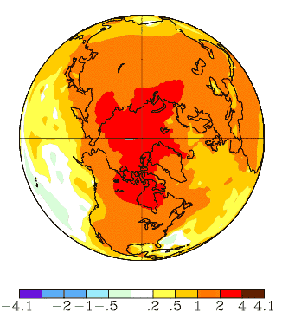

Figure 1. Change of annual surface air temperatures (ºC) over the 50-year period, 1963-

MANUSC

2012. Plotted values are differences between initial and final points of linear regression trend line for each point. Source: NASA Goddard Institute for Space Studies, http://data.giss.nasa.gov/gistemp/maps/

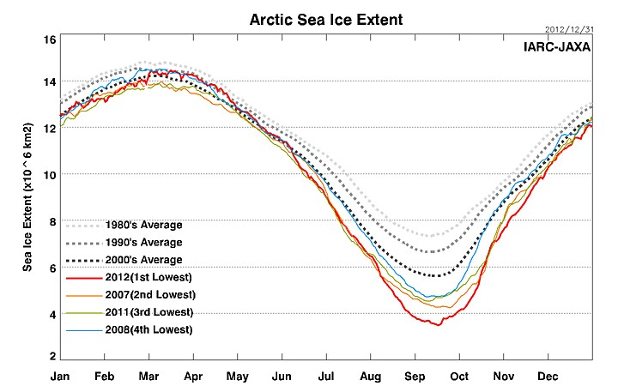

Figure 2. Annual cycle of Arctic sea ice extent for 2012 (red), 2007 (orange), 2011 (green) and 2008 (blue). Dashed lines show decadal means for the 2000s (black dashes), 1990s (gray dashes) and 1980s (light gray dashes). Source: IARC/JAXA Sea Ice Monitor, http://www.ijis.iarc.uaf.edu/en/home/seaice_extent.htm

MANUSCRIPT

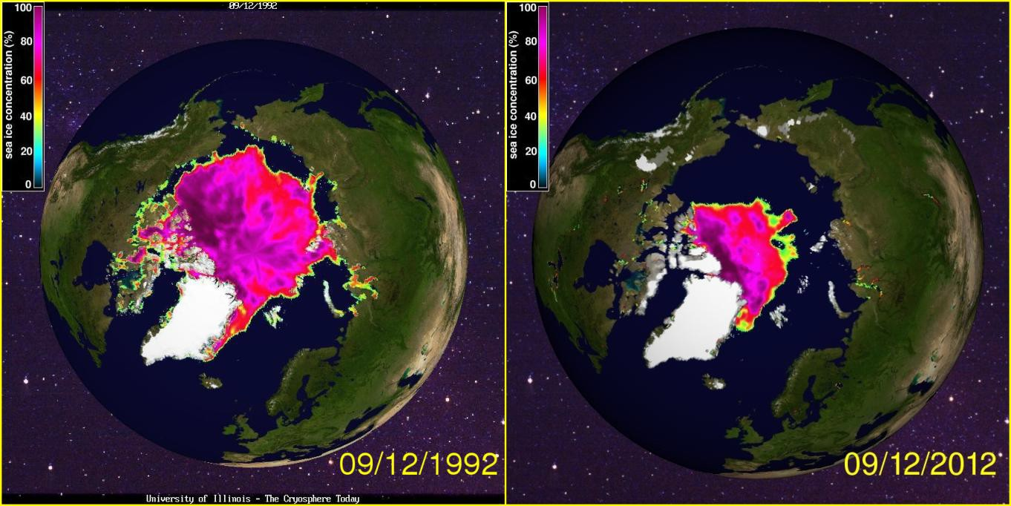

Figure 3. Comparison of Arctic sea ice concentrations on September 12, 1992 (left) and September 12, 2012. Source: University of Illinois, Cryosphere Today, http://arctic.atmos.uiuc.edu/cryosphere/

MANUSCRIPT

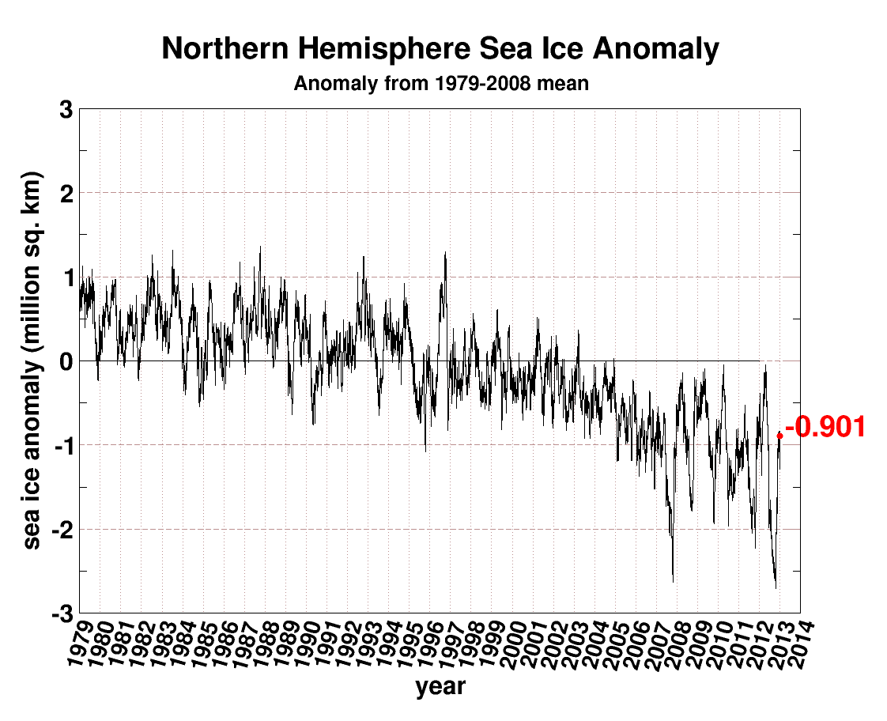

Figure 4. Departure of daily Arctic sea ice-covered area from corresponding daily means for 1979-2008. Source: University of Illinois, Cryosphere Today, http://arctic.atmos.uiuc.edu/cryosphere/

MANUSCRIPT

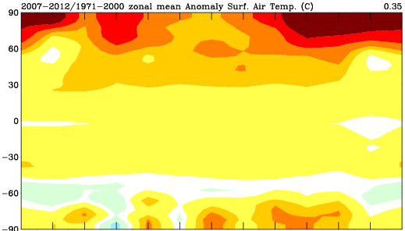

JAN FEB MAR APR MAY JUN JUL AUG SEP OCT NOV DEC

ºC

MANUSCRIPT

Figure 5. Differences between mean temperatures (ºC) of 2007-2012 and the climatological means for 1971-2000. Temperature differences are plotted by calendar month (x-axis) and latitude (y-axis, positive for ºN).

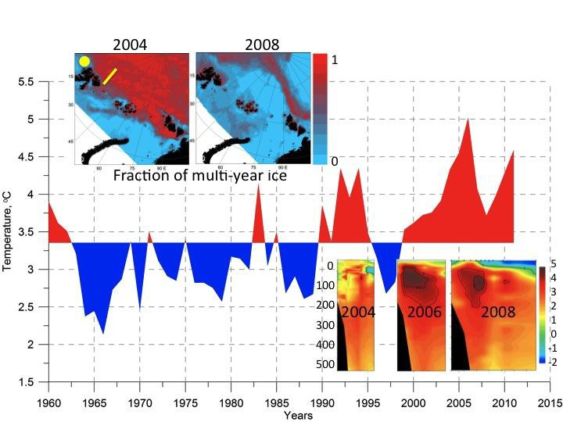

Figure 6. Temperature (relative to the mean for 1980-2011) of North Atlantic Ocean water entering the Arctic Ocean west of Svalbard (yellow circle in inset at upper left). Red shading denotes positive departures, blue shading negative departures. Upper insets show fractions of multiyear ice in 2004 and 2008. Lower insets show cross-sections (yellow line in upper left inset) of water temperature in 2004, 2006 and 2008. From Alexeev at al. (2013).

MANUSCRIPT

MANUSCRIPT

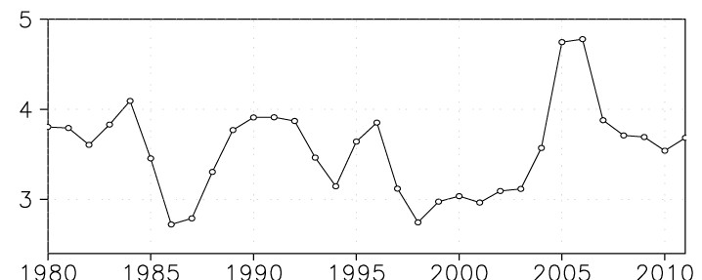

Figure 7. Poleward transport of moisture (kg m s-1) across 75ºN computed from the ERA- Interim reanalysis. Source: V. Alexeev, International Arctic Research Center.

MANUSCRIPT

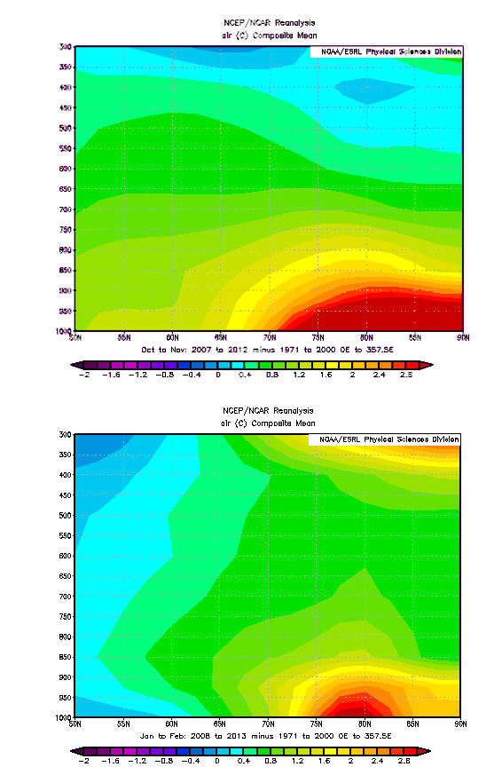

Figure 8. Latitude-height cross-section of temperatures of 2007-2012 (50-90ºN) relative to means for 1971-2000. Upper panel is for October-November, lower panel is for January- February. Source: NOAA Earth System Research Laboratory, NCEP/NCAR reanalysis.

ACCEPTED

MANUSCRIPT

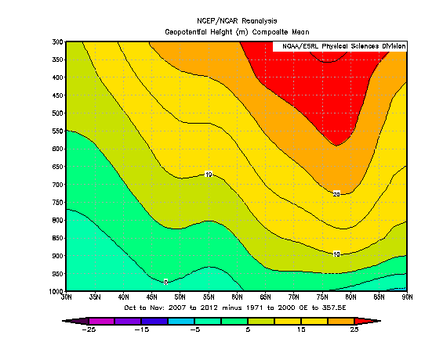

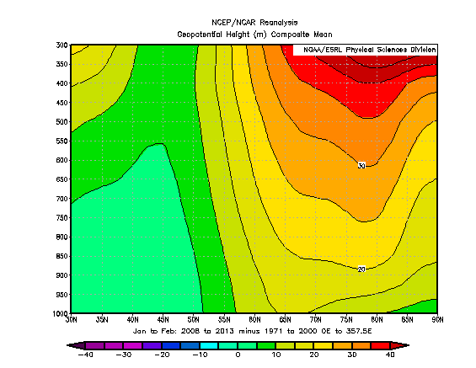

Figure 9. As in Figure 8, but for geopotential height (m).

ACCEPTED

MANUSCRIPT

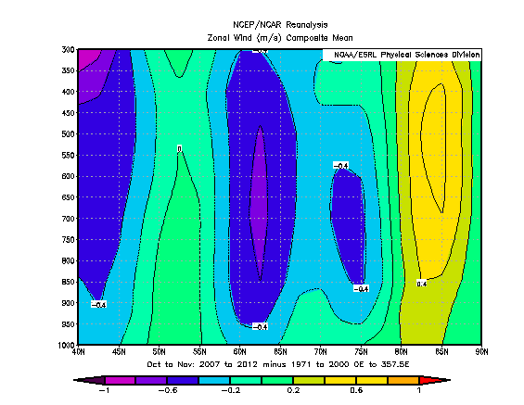

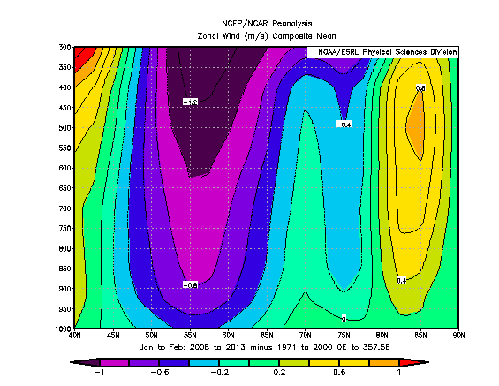

Figure 10. As in Figure 8, but for zonal (eastward) wind speed, m s-1.

ACCEPTED

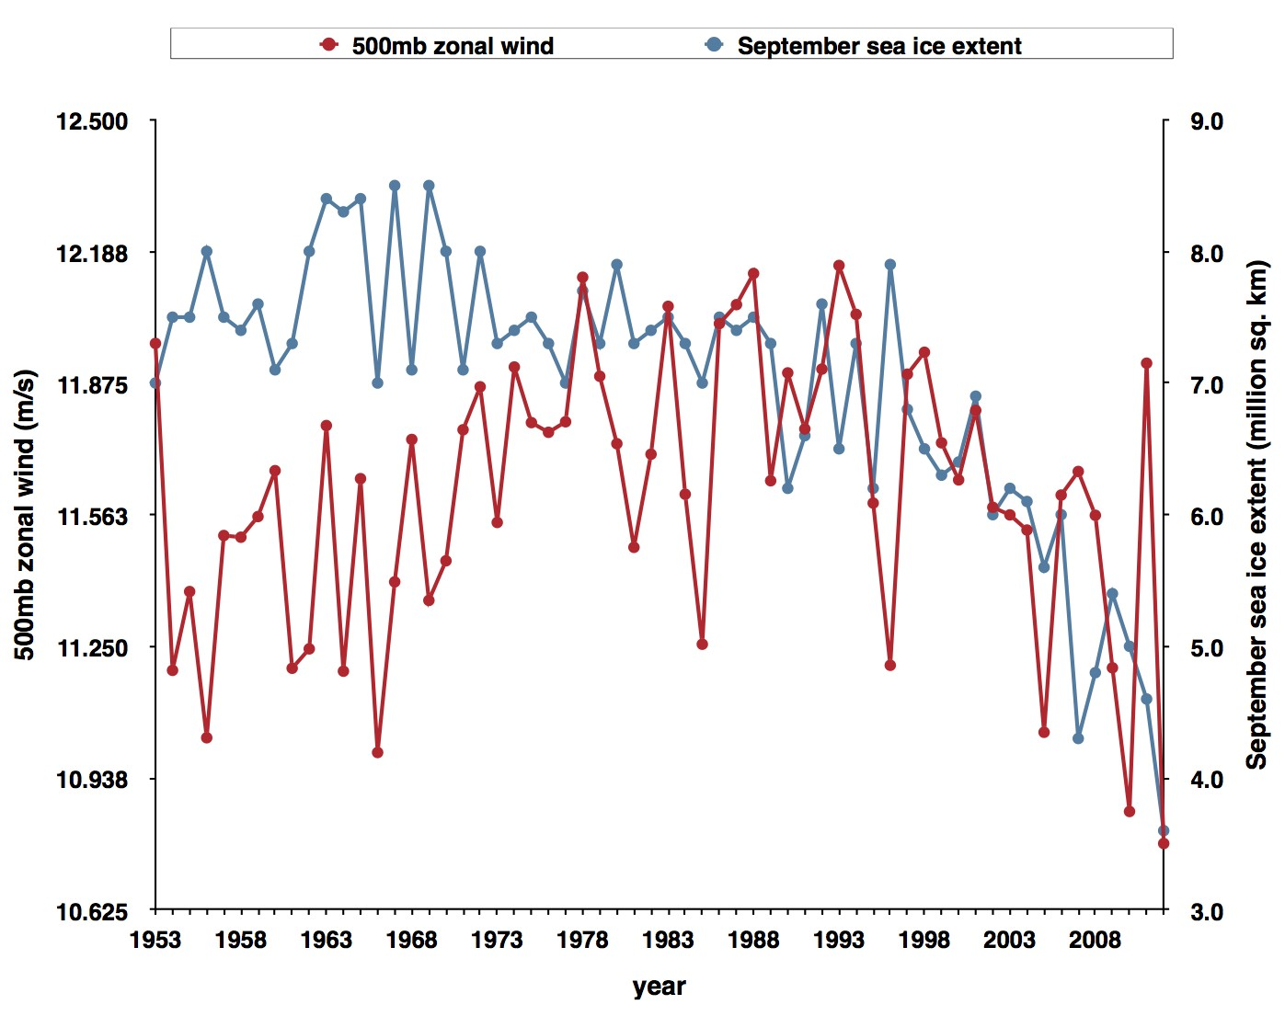

Figure 11. Red line shows yearly values of October-December zonal (west-to-east) windspeeds (m s-1) at 500 hPa averaged over 30-70°N; blue line shows September sea ice extent (millions km2). Time period is 1953-2012, inclusive. Source: NOAA Earth System Research Laboratory NCEP/NCAR reanalysis (zonal winds) and Meier et al. (2012) (sea ice extent).

MANUSCRIPT

ACCEPTED

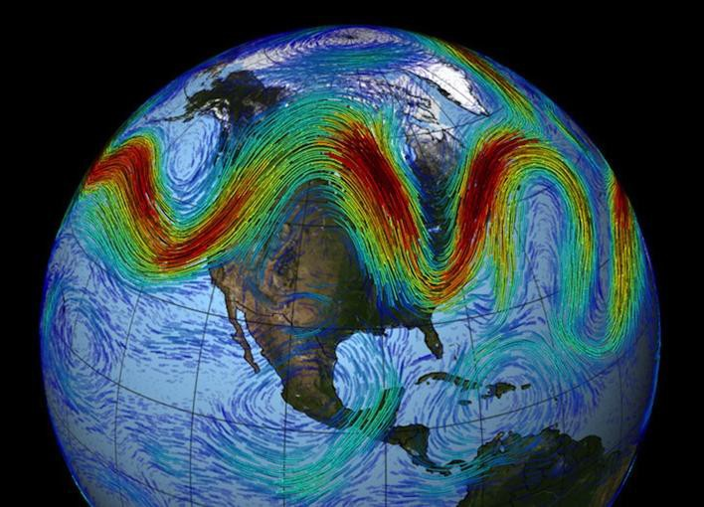

Figure 12. Schematic depiction of jet stream, with troughs (southward excursions) and ridges (northward excursions) that amplify in regimes of atmospheric blocking. From NASA, http://www.giss.nasa.gov/research/news/20120313/629341main_Earth_jet_stream.jpg

MANUSCRIPT

